Missouri ESO Newsletter-Oct/Nov 2022
The Second Worst Restaurant in France by Alexander McCall Smith. Sent by Mary Ridge.
Paul Stuart intends to spend time writing a book on the philosophy of food while visiting his older cousin Chloe in a small village in France where she has rented a house. But, Paul is stricken with food poisoning eating mussels at the village restaurant with the reputation of the book title. They soon become embroiled in the lives of the restaurant’s chef, his nephew, the waitress who gives birth in the kitchen, the baby Aramis, and the twin sisters who own the home Chloe has rented. This is the second book in another series by this author. I enjoy the charm and wit in his books.

Mounting Fears by Stuart Woods. Sent by Amy Boone.
President Will Lee is having problems. His Vice President has just died on the operating table. The governor he wants to replace the VP has a squeaky clean reputation, but is this a façade or are some skeletons in the closet? Teddy Fay is trying to sabotage his wife. At the same time, there are issues in Pakistan that could cause World War III. This book has numerous Woods characters in it.

The Wedding Veil by Kristy Woodson Harvey. Sent by Marilyn Stone.
Moving back and forth between current day and the 1914’s this is a story of a wedding veil that was supposed to bring good fortune and happiness to all of the brides who wore it when marrying their true love. Julia Baxter was about to marry her on-again, off-again fiancé but at the last minute she cancels the wedding. She does not feel she can wear the veil in good faith. The historical part of the story deals with the Biltmore Estates in Asheville, NC and the life of Cornelia Vanderbilt who became disillusioned with all the publicity surrounding her family. She also escaped from this life; the wedding veil is a connection between these two stories. Well told and based on some historical facts.

I Am Somebody, Emerging From the Shadows by Sharon Schmitz. Sent by Margaret Richardson.
This is an amazing book by Sharon Schmitz as she recounts her 29-year history working with traumatized women, mentally ill women, and the criminal system, and how she was the primary founder of Women In Transition in St. Louis program. These are the stories of the lives of some of these women, their incarcerations, their history of abuse all throughout their lives, where they have been and how they are trying to overcome their past.

Scarlett by Alexandra Ripley. Sent by Debbie Barber.
Scarlett O’Hara thinks she has her life figured out. When she finally decides she loves Rhett Butler he has decided to move on. Thinking he will come running for her she goes to visit her homeland in Ireland. There her life takes on a whole new meaning. Having burned bridges in the states she decides to make a life for herself in Ireland. There is a problem with the plan. Her Ireland family doesn’t see things the way she does and Rhett is still in Charleston. Very much enjoyed this book.

The Last House on the Street by Diane Chamberlain. Sent by Kathy Baylor.
This is a great book. The two main characters have different stories but are destined to find out some hard truths from the past that affect their futures. Ellie was a college student who fought for civil rights in her home state of North Carolina during the 1960’s. Kayla is a young widow with a 3 year old daughter moving to a new house in Ellie’s home town. When the two meet they discover what tragedies occurred 40 years earlier.

No Land to Light On by Yara Zgheib. Sent by Connie Robley.
This book is about a young Syrian couple. Sama had come to America on a Harvard scholarship. She loves the freedom of America and the education she is receiving. She meets Hadi, who also has arrived in America from Syria, but comes as a refugee. They meet at a party and fall in love. She becomes pregnant and they both are thrilled to be bringing and raising a child in the US. However, Hadi’s father dies, and he feels that he must return to attend the funeral. On the day he is to return to the US, Sama goes to the airport to meet him but he is not on the plane. She does not realize that he can’t return to the States due to a newly imposed travel ban. This is a heartbreaking story of two people who are desperately trying to reunite and want to give their child a life and freedom that they never experienced when they were growing up.

The Complete Cookbook for Young Chefs by America’s Test Kitchen. Sent by Pam Carr.
The first 10 pages of this great kids cookbook explains in easy terms how to interpret the recipes in the book through words, symbols, and pictures which is followed by a great section on listing secrets to success in the kitchen. It explains how to measure, chop, garnish, and plate the food and discusses the tools needed and their uses. Each of the 100+ recipes are designed with children in mind. What’s appealing and healthy to them. Great book. (sounds like a great Christmas gift!)

The Secret Diary of Hedrink Groen 83 ½ Years Old by Hedrink Groen. Sent by Cathy Judy.
I think I laughed more reading this book than any book I’ve ever read. It’s set in an independent living center where a group of residents call themselves inmates. They form a club (Old But Not Dead) and begin planning outings and activities to keep them young at heart. They truly are the best rebels I’ve ever read about and want to be part of this club. Highly recommend.

The Brillant Life of Eudora Honeysett by Annie Lyons. Sent by Alicia Thomas.
Eudora is a cranky 85 year old woman who has lived in the same house all her life. She has witnessed the indignities and suffering of old age and has lived a full life. She isn’t leaving things to chance. Her end will be on her terms. With a call to an assisted death clinic in Switzerland, she sets her plan in motion. She meets her 10 year old neighbor, Rose. She is a pint sized rainbow of sparkling cheer. All Eudora wants is to be left alone but she finds herself embarking on a series of adventures with Rose and a recently widowed neighbor Stanley. As the trio of unlikely friends grow close Eudora realizes she must come to terms with what lies ahead. Now that her life has been rekindled, how can she possibly say goodbye?

Bronze Drum by Phong Nguyen. Sent by Bethel DeSpain.
A very good story of two Trung sisters in LacViet of Vietnam. They study with a tudor and train during the day. When their father and one of the sister’s husband in killed by the Han Chinese, the sisters gather an army of women to fight the Han. It is fiction based on a true story of the Trung sisters.

The Life She Was Given by Ellen Marie Wiseman. Sent by Rosemary Douglas.
A captivating story that takes place in two different times. It tells of how people responded to life issues back then, that now are considered cruel and insensitive, yet that “was the way it was done back then”. A story of resiliency and overcoming obstacles.
The Last Garden in England by Julia Kelly. Sent by Robyn Pipkin.
Weaving the stories from 3 generations, this novel takes on gardening, romance, mystery, and history. I liked this book.

The Fire and the Ore by Olivia Hawker. Sent by Zona Burk.
In the 1850’s, President Buchanan is dealing not only with a divided nation over slavery, but with Brigham Young and the Mormon Church rising as a formidable force out in Utah. The US has declared war on polygamy as a form of slavery. And I learned about a different civil war in our country’s history. Hawker relates the stories of three young women and their incredible experiences during this time. While the book is historical fiction, the 3 main characters and their described journeys are all very real. Hawker’s great great grandmother Jane is one of the characters.

Skeletons on the Zahara: A True Story of Survival by Dean King. Sent by Barbara Phillips.
This author did a lot of research about the Commerce, a ship that wrecked off the west coast of Africa in 1815. This research included reading the memoirs of two of the survivors, Captain Riley and Seaman Robbins. The crew was captured and enslaved by Arabs in the desert and suffered greatly from the harsh conditions. I had never heard of this shipwreck before getting this book. I don’t know how any of them survived.

Me Before You by Jojo Moyes. Sent by Rev. Linda Wansing.
A romance novel where Louisa, an ordinary girl, who is living an ordinary life begins working for a paraplegic. She ends up showing him that life is worth living. I really enjoyed this book.

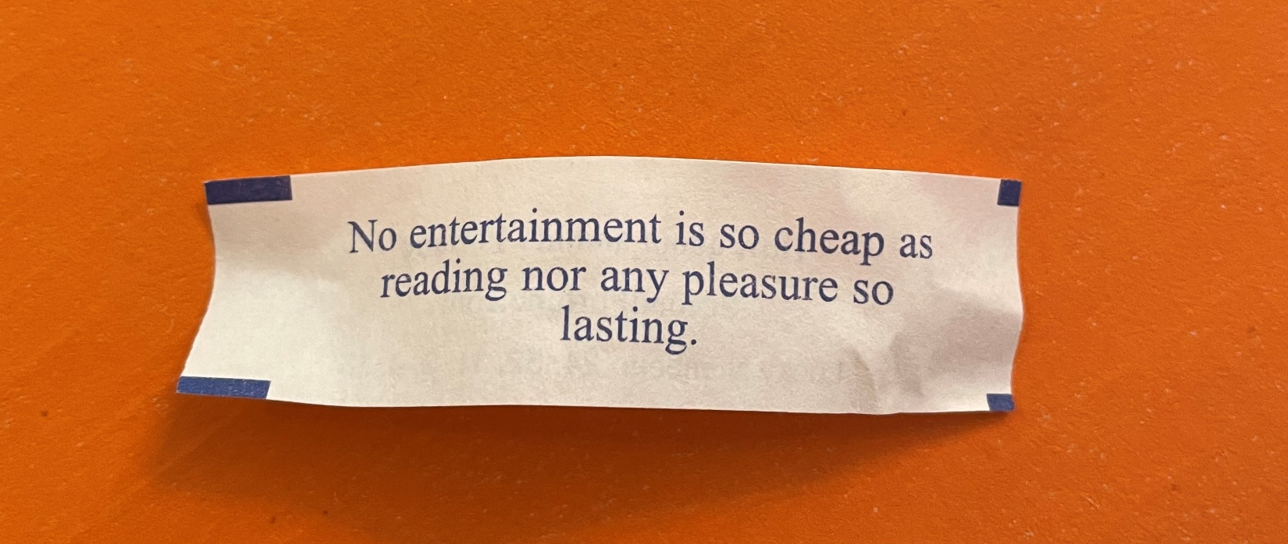

If anyone is interested in the review of The Wedding Veil that was on facebook, you can email our international chairman, Sandy at sandygfwc@outlook.com. The review was recorded and she will send you the link.
Thanks to all our readers. Happy reading!! GFWC MO ESO reader Rosemary Douglas received the above fortune in her cookie recently!!! Let us all be thankful and grateful for all that we have and all that we do!

Lisa Cook
GFWC MO ESO Chairman 2022-2024

