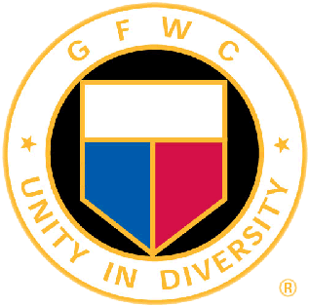
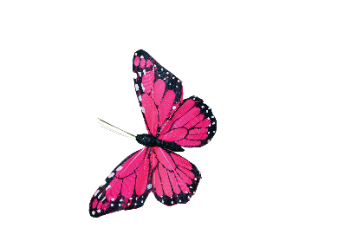
GFWC 2022-2024 ENVIRONMENT
Chairman: Tina Neese, Ed.D., LPC
tinanneese@gmail.com 678-458-0337
Volume One July 2022 Newsletter

Inside this Edition:

Welcome to the GFWC Environment CSP! It is my pleasure to serve as your chairperson for the 2022-2024 administration. My goal is to provide as much information possible to you for you to be able to pass on important information, project ideas, and facilitate any discussions needed for you to be successful. I will send monthly newsletters and host several meetings for the State CSP chairmen via Zoom throughout the administration. Please always feel free to share this newsletter with your clubs in your state.

If you need to contact me, here is the contact information:

Tina Neese, Ed.D., LPC
1211 Spring Marsh Court NE
Gainesville, GA 30501
Cell: 678 458 0337
Email: tinanneese@gmail.com and tinadaniel1224@gmail.com

Private Facebook Page:
I invite the State Environment CSP chairmen and any Board of Director member to join the private Facebook page: GFWC Environment CSP (GFWC Environment CSP). Various ideas, announcements, guest speakers, and video presentations will be presented.

First meeting for State Environment CSP’s:
September 11, 2022 8:00 EST

- Facebook Private Group:
GFWC Environment CSP
- Important Calendar Dates

Other News in this Edition:
- Understanding the Environment CSP
- Featured Author

Quote of the Month:
“I went to the woods because I wished to live deliberately, to front only the essential facts of life, and to see if I could not learn what it had to teach, and not, when I came to die, discover that I had not lived.” – Henry David Thoreau

Understanding the Environment CSP
There are four target areas in this CSP:
- Preserve Resources:
This area relates to but not exclusive of forestation, Earth Day activities, reduction of energy consumption, air and water pollution, wetland conservation, water projects, disposable of waste, and gardening. Club Project Example: Prepare a presentation about your watershed for a school or community. Discuss water quality threats, including the dangers of polluted runoff and ecosystem loss.

- Protect Wildlife and Domesticated Animals: This area relates to but not exclusive of birding projects, Audubon Society, native plants for animal food, Department of Natural Resources, preserving Wildlife Management Areas, endangered species protection, wildlife protection, and animal shelter and humane society support. Club Project Example: Be a bird watcher; contribute by gathering scientific data.

- Live Sustainably:
This area relates to but not exclusive of recycling, zero waste projects, the Environmental Protection Agency, sustainable gardening, locally grown food, renewable energy, reduce consumption of purposes, reusable items, and upcycling of items. Club Project Example: Host a fun time with upcycled items for purchase.

- Beautify Communities and Enjoy Nature:
This area relates to but not exclusive of adopt-a-highway, clean up days, nature walks, teaching others about nature, yard of the month, garden tours, master gardening, plant and tree identification, hiking and biking, National and State Parks, and clean water projects. Club Project Example: Be a part of your communities Clean and Beautiful, host a trash pick-up day in your community, or volunteer at a national or state park.

Environment CSP Resolutions
There are 12 resolutions in this CSP as of 6/1/2022. Each month we will explore one resolution and its meaning for GFWC membership. They will be listed in upcoming newsletters after the 2022 convention and any changes are made. This will begin in the Fall.
Free website resources to explore and share with educators and families for children:
www.aubudon.org
www.nationalgeographic.org
www.nature.org
www.seacoastsciencecenter.org
www.worldwildlife.org

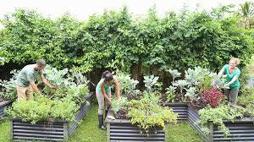
34 Ways to Reduce your Carbon Footprint
Choose organic and local foods in season. Buy foodstuffs in bulk. Reduce food waste and compost when possible. Eat low on the food chain.
Don’t buy fast fashion. Buy vintage or recycled clothing. Wash clothes in cold water. Buy less stuff. Use reusable bags and avoid excess packaged items. Opt for a laptop instead of a desktop. Purchase energy efficient products and support environmentally friendly companies.
Do an energy audit. Change light bulbs to LEDs. Turn off lights. Turn down water heaters. Install a low-flow shower head. Lower thermostat in the winter and raise it in the summer.
Drive less. Avoid unnecessary braking and acceleration. Take care of your car. Reduce driving. Use traffic apps and cruise control. Use less A/C. Purchase a hybrid car.
Avoid flying or fly non stop. Go economy. Vote!

Important Dates for July
Monthly celebrations: National Park and Recreation Month, National Baked Bean Month, National Hot Dog Month, and National Blue Berries Month.
July 1 Battle of Gettysburg (1863)

First US Zoo (Philadelphia, 1874)
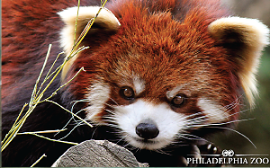
In its first year of operation the zoo had 813 animals and received more than 228,000 visitors. Today, it has more than 1300 animals, many of them rare and endangered. They have more than 1.2 million visitors annually.

July 2 Jean Craighead George birthday (1919), author of Julie of the Wolves

July 3 A/C Appreciation Day
Dog Days of Summer begins (through Aug. 11)
Idaho becomes the 43rd state (1890)
Stay Out of Sun Day

July 4 Earth at Aphelion (Earth farthest from Sun)

July 7 Father-Daughter Take a Walk Day

July 10 Don’t Step on a Bee Day
Wyoming becomes the 44th State (1890)

July 11 UN World Population Day
E.B. White birthday (1899), author of Charlotte’s Web

July 12 Henry David Thoreau birthday (1817), poet and environmental scientist

July 16 Ronald Amundsen birthday (1872), discovered the South Pole in 1911
Atomic Bomb tested (1945) in NM
Washington DC established as capital (1790)
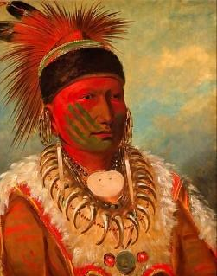
July 24 Pioneer Day Anniversary (1847)

July 26 George Caitlin birthday (1796),
American artist known for
Native American art, shown here
No-Ho-Mun-Ya (1844)
Author Feature: Jean Craighead George
Jean was born into a family of naturalists and spent many weekends hiking, camping, and climbing near the Potomac River. They studied falcons, gathered edible plants, and made fishhooks from twigs. Her first pet was a turkey vulture. She was a journalist but returned to her love of nature when her children were born, bringing home owls, robins, mink, seagulls and tarantulas. They had over 173 wild animals in their home and yard. These animals were often characters in the over 100 books she wrote. With her love of animals, she studied wolves in Alaska and this was how her award-winning book Julie of the Wolves was born.
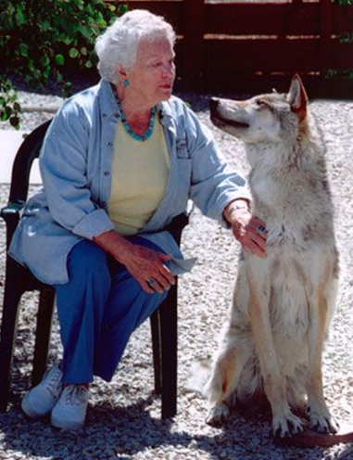
Pictured here:
Jean Craighead George

National Park and Recreation Month
In addition to visiting a park or recreation area, you can get involved in Park and Recreation Month by:
- Have July proclaimed as Park and Recreation Month in your community.
- Use the official logo, social media graphics and the hashtag #OurParkAndRecStory
- Sharing stories from your community members about what parks and recreation mean to them on social media with the hashtag #OurParkAndRecStory.
- Participating in Park and Recreation Professionals Day on July 16, 2021.
- Downloading the official Park and Recreation Month poster and hanging it up, taking pictures with it or sharing copies of it with your community.
- Download the PR Materials from nrpa.org for more ideas and messages to support parks and recreation highlighting the benefits of park use.
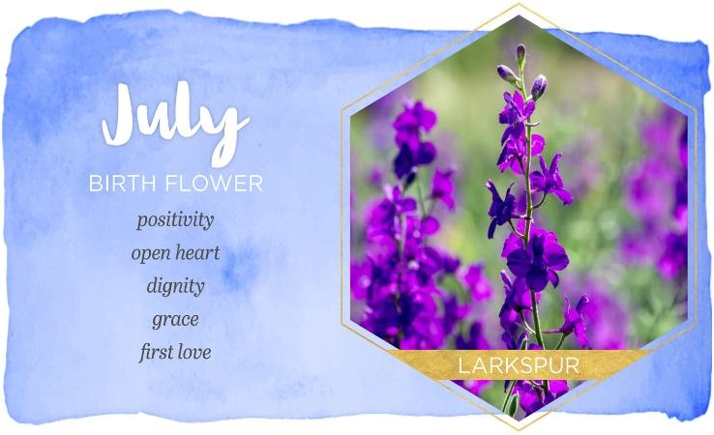Flower of the Month: Larkspur (Delphinium)
The birth flower for July is the delphinium, also known as larkspurs. Delphiniums are gorgeously bright flowers that brighten up many gardens in early summer. They are known for their vibrant, blue color and impressive height. They can grow to be about 6 foot tall! They will definitely be easy to spot if you are out for a walk.

Fun fact! The delphinium name came from the Ancient Greeks who thought the shape of the new flower bud looked like a dolphin's nose. However, delphiniums are more commonly known as larkspur, named after the claws of a lark.

With over 400 different types of delphinium, these flowers really are the star of the show in summer country gardens! Larkspur is said to symbolize joy, warmth and fun. Blue delphiniums have a meaning of dignity, while white, pink and light blue delphiniums mean youth and renewals. If you are born in this month, you might be the life of the party! Charming, bubbly, bright and with a great sense of humor, people are naturally drawn to you. You can make anyone feel welcome and appreciated with your outgoing personality.

They were first introduced to England from Italy in the 16th century. They did not take long to gain popularity. Early colonists brought them to America, where they became centerpieces in colonial gardens. They can also be used for indoor decor as cut flowers in vases.

Larkspur flowers are easy to grow and even easier to take care of. They can tolerate most soils and grow well in full sun, as long as the soil is moist. They do self-sow and can become invasive in a garden. Find more information on growing larkspur at www.gardening channel.com.

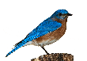
Bird Buzz
Bird watching is a fun hobby for newbies to the activity that anyone can do anywhere, anytime and without spending much money. It can be done at home, car window, or while taking a rigorous hike.
Members can do this for fun or to keep a “life list”, a term used for the running list that bird enthusiasts keep of all the different birds they see. It is rewarding to hear various sights and sounds of beautiful and interesting feathered creatures, especially in the spring and fall.
How to get started:
Walk outside or peer out your window. Birds hang out in backyards, especially if you have bird feeders. Fill up the feeders with birdseed. Black oil sunflower seed is a good choice. Sit back and see how many different species show up. Add millet and safflower, seeds that will deter squirrels. Birds are attracted to water so add a fountain or birdbath where bids can bathe and drink.
Find a good book guide or phone app. Bird watching is about looking and listening. Recommendations are National Geographic’s Complete Birds of North America, Sibley Backyard Birding Flashcards, and the phone app Merlin by Cornell Lab of Ornithology.
Invest in binoculars. It makes it easier.
Seek out different locations. Various birds like different locations like tall trees, shrubs, nests along a stream or open fields. City parks can also be amazing places as they act like an oasis in a sea of concrete for birds.
Connect with local birders.
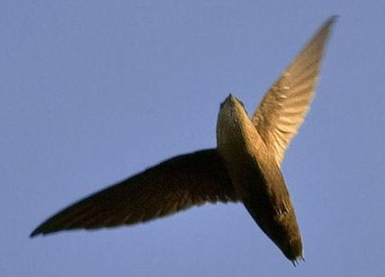
Become a morning person. Birds sleep at night and are hungry in the morning. Avoid noontime as this is when birds are the least active.
Chimney Swift, often called the flying cigar, is a familiar sight in cities and towns. They are a dark charcoal with tiny feet, useless for walking but perfect for clinging to a chimney. They typically live in manmade structures, eat insects, and ratio wise have the longest wings of any bird.
Our States
Learn each month about a different states from their flora and fauna to state birds, trees, flowers, and parks.
Featuring: ALABAMA
Alabama entered statehood on December 14, 1819 and became the 22nd state. The state is named after the Alabama Indian tribe that inhabited the area until the early 19th century. The capitol is Montgomery. The highest point is Cheaha Mountain at 2407 feet above sea level and the lowest point is where AL meets the Gulf of Mexico. The official state creed of Alabama was originally created for the Alabama Federation of Women’s Clubs by member Mrs. H. P. Thetford and adopted in 1953.
State Bird: Yellowhammer, a variety of a woodpecker
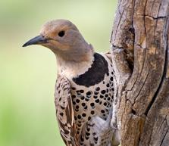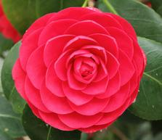
State Flower: Camellia
State Wildflower: Oak Leaf hydrangea
State Game Bird: Wild Turkey
State Mammal: Black Bear, once common in the area and under conservation efforts and found mainly in the Mobile area (Florida Black Bear species)
State Insect: Monarch Butterfly
State Tree: Southern Longleaf Pine

TripAdvisor rates Gulf State Park the best state park in Alabama. Alabama has 60 miles of coastline. Its coastline, home to the beaches of the Gulf of Mexico, is an important economic and environmental asset to Sweet Home Alabama.

Alabama has 22 million acres of forest, 67% of total land area in the state. Much of the northern part of the state is hilly and mountainous with the central, west and southern parts being more grassland plains.

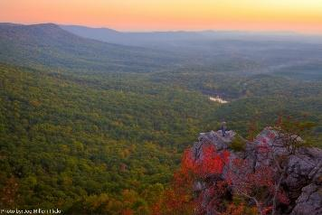
Cheaha State park, with its 2799 acres, is the oldest continuously operating state park and opened to the public in 1933.

State Parks: 24
Bladon Springs State Park
Blue Springs State Park
Bucks Pocket State Park
Cathedral Caverns
Chattahoochee State Park
Cheaha State Park
Chewacla State Park
Chickasaw State Park
Claude D Kelley State Park
De Soto State Park
Elk River Lodge State Park
Florala State Park
Gulf State Park
Joe Wheeler State Park
Lake Guntersville State Park
Lake Lurleen State Park
Monte Sano State Park
Oak Mountain State Park
Paul M Grist State Park
Rickwood Caverns State Park
Roland Cooper State Park
Tannehill State Park
W F Jackson State Park
Wind Creek State Park
State Forests: 3
Geneva State Forest
Little River State Forest
Weogufka State Forest
State Wildlife Management Areas: 4
Barbour County Wildlife Mgmt. Area
Demopolis Wildlife Mgmt. Area
Lauderdale Wildlife Mgmt. Area
Scotch Wildlife Mgmt. Area
National Park : 1
Muscle Shoals National Heritage Area
National Forests: 4
Conecuh National Forest
Talladega National Forest
Tuskegee National Forest
William B Bankhead National Forest
National Historic Sites: 2
Tuskegee Airmen National Historic Site
Tuskegee Institute National Historic Site
National Monuments: 2
Birmingham Civil Rights National Monument
Freedom Riders National Monument
National Wildlife Refuges: 9
Blowing Wind Cave National Wildlife Refuge
Bon Secour National Wildlife Refuge
Cahaba River National Wildlife Refuge
Choctaw National Wildlife Refuge
Eufaula National Wildlife Refuge
Fern Cave National Wildlife Refuge
Key Cave National Wildlife Refuge
Watercress Darter National Wildlife Refuge
Wheeler National Wildlife Refuge
National Parks of the United States
The US has 63 National Parks, which are government designated protected areas operated by the National Park Service. National Parks are designated for their natural beauty, unique geological features, diverse ecosystems, and recreational opportunities. Eight national parks, six of those in Alaska, are paired with a national preserve.
President Grant signed a bill creating the first National Park, Yellowstone, into law in 1872. The National Park Service was created in 1916 to help conserve the scenery and the wildlife, as well as to provide enjoyment of the area for future generations.
Thirty states have national parks. California has the most (9), followed by Alaska (8), Utah (5) and Colorado (4). The largest park is Wrangell-St. Elias in Alaska with over eight million acres. The smallest park is Gateway Arch National Park in St. Louis, MO at 192 acres. The total acreage protected by national parks is 52.2 million.
Great Smoky Mountains National Park in TN and NC has been the most-visited park since 1944 followed by Arizona’s Grand Canyon National Park. The newest national park is New River Gorge, which was previously named a national river, and the newest recent park in its entirety is National Park of the American Samoa.
Acadia National Park
I had the pleasure of traveling to Maine and seeing this stunning area on my honeymoon. Acadia National Park was established 2/26/1919 and covers 49,076 acres. Covering most of Mount Desert Island and other coastal islands, Acadia features the tallest mountain on the Atlantic coast of the US with granite peaks, ocean shoreline, woodlands and forests. There are freshwater, estuary, forest and intertidal habitats.
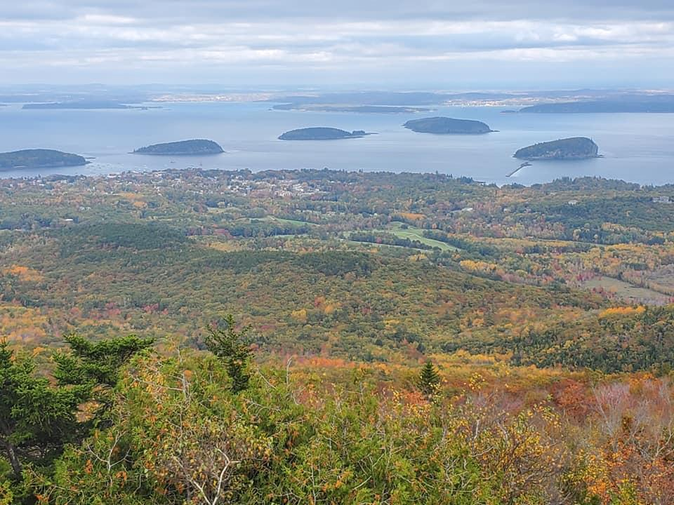
Photo courtesy of Tina Neese, Oct 2021
American Samoa
The southernmost national park is on three Samoan islands and protects coral reefs, rainforests, volcanic mountains and white beaches. The area is also home to flying foxes, brown boobies, sea turtles, and 900 species of fish. It was established on October 31, 1988 and covers 8,256 acres.
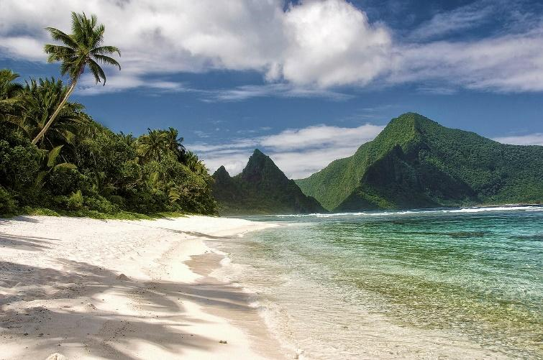

How can clubs help with national or state park areas?
Celebrate the month of July as National Recreation and Park Month. Donations are helpful to parks. Create a fundraising page on your club’s social media page. Become a friend of the National Park Foundation. Donate in honor or memory of a club member.
As a club, be an “Adopt-A-Trail” volunteer group throughout the year, especially during the summer months. Things involved in helping with trails includes patrolling/maintaining the trail four or so times per year, picking up and bagging litter, clearing trails of small debris, and removing small branches to name a few.
Millions of Americans live full time in their RV’s and the National Park Service has installed long-term RV hookups at public parks across the US for volunteers, allowing them to stay free in exchange for a certain number of hours of service to help maintain these precious lands. This Volunteers-in-Parks (VIP) program has existed for 50 plus years and more than 300,000 people volunteer their time and talent to national parks annually. Volunteers greet campers, explain the rules, and provide information.
Kids Corner
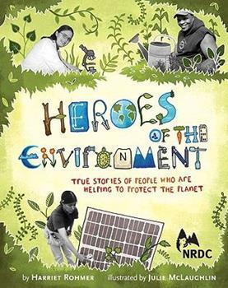
Each month find a few environment friendly children book recommendations. Use these books as a stepping-stone to teaching children and teenagers about environmental topics.
Heroes of the Environment by Harriett Rohmer is an inspiring book of 12 true stories of people across North America who have done great things for the environment. Stories include a teenage girl who figured out how to remove an industrial pollutant from the Ohio River to a superstar wrestler who works to protect turtles and whales, and a teenage boy from Rhode Island who helped defective state recycling programs.
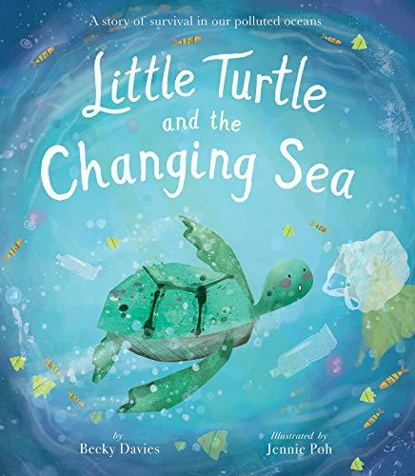
Little Turtle and the Changing Sea by Becky Davies and Jennie Pohl is about a little turtle who loves the ocean to only find out how much it has changed. This book helps youngsters discover the struggles facing marine life as plastic invades their home. At the end are tips on how to help.
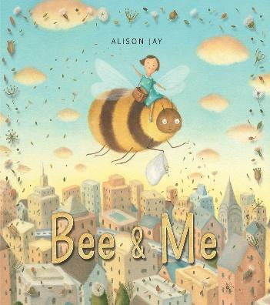
Bee & Me by Alison Jay helps young readers learn the importance of bees in our ecosystem. This would be a great introduction to bee keeping and using honey to show the importance of bees.

Other books: “10 Things I can do to help my world” by Melanie Walsh, “The Water Princess” by Susan Verde, “Green” by Laura Vaccaro Seeger, “The Great Kapok Tree” by Lynne Cherry, “Compost Stew” by Mary McKenna Siddals, “Miss Maple’s Seeds” by Eliza Wheeler, “Touch the Earth” by Julian Lennon, and “Kenya’s Art – Recycle, Reuse, make Art!” By Linda Trice.
Endangered Species

A species is endangered when its population declined between 50-75% and when its adult population is less than 250. There are now 41,415 endangered animals and plants species and 16,306 of those are threatened with extinction.

Here are the top two endangered species followed by a list of eight more:

Javan Rhinoceros – critically endangered with only a population of 60 and the most threatened large mammal species. They lived in tropical forests and are confined to one park in the southwest tip on the island of Java in Indonesian. 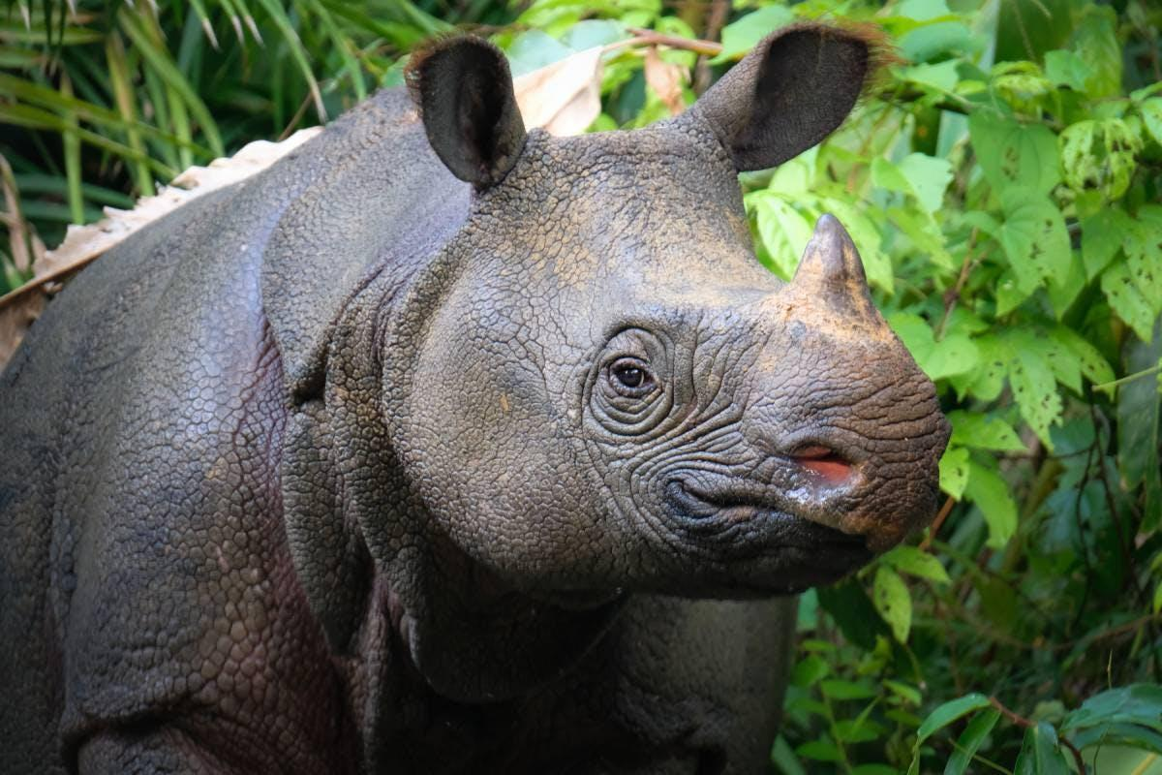

Vaguita – a small harbor porpoise native to the Gulf of California/Mexico. It is the smallest known dolphin alive today. There are as few as 10 left.

Mountain Gorilla – around 1,004 (increase from 620)

Tiger – around 3,2000 remain in the wild today

Asian Elephant – examples on ways to help include supporting the ban of ivory trade, choose elephant-friendly coffee, choose ethical tours, support elephant sanctuaries and adopt an elephant. (20,000+)

Orangutans – around 105,000 estimated today

Leatherback Turtles – 25,000 females in the wild

Snow Leopard – 4,000-6,500 population left

Irrawaddy Dolphins – 92 are estimated to exist

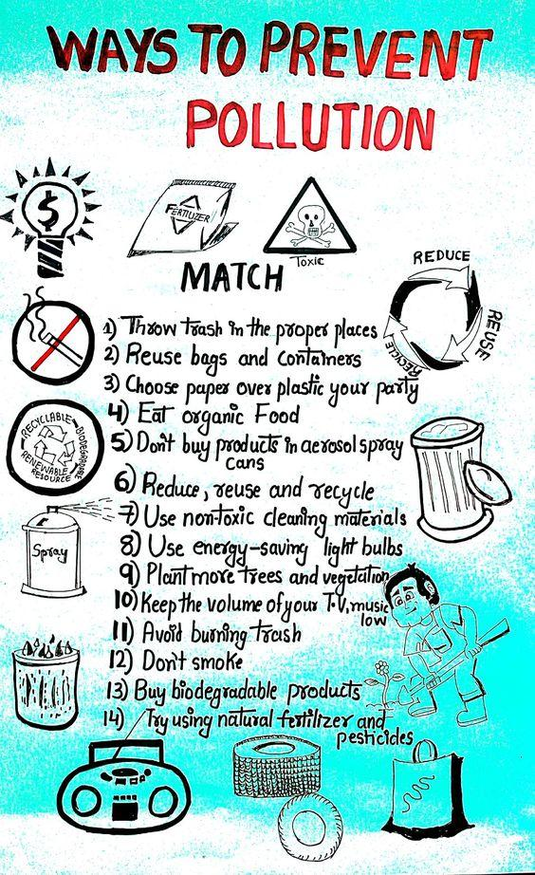
Eat an Apple, Save a Dolphin!
Junk food is fattening but it is also responsible for most of the world’s ocean trash. The International Coastal Cleanup 25 years of records indicates that eight of the nine types of trash floating around in the ocean comes from humans food purchases. While not the largest and most toxic, the wrappers, lids and bottles are the MOST COMMON and the MOST DANGEROUS form of debris for marine animals and birds.
The largest factor of ocean pollution is plastic. Over the last decade, we have produced more plastic than in the last 100 years. Plastic kills fish, birds, marine mammals and sea turtles. It destroys habitats and affects mating rituals, which can wipe out an entire species.
AFFILIATE ORGANIZATION CORNER
Our affiliate organizations offer GFWC unique and customized services including materials, speakers, kits, or other information designed for GFWC clubs.
Heifer International (www.heifer.org): provides gifts of livestock and environmentally-sound agricultural training to improve the lives of those who struggle daily for reliable sources of food and income.
Club Project Idea:
“Pig Out”: Partner with a local BBQ restaurant to host a night where members work for tips to purchase a pig; have a donation jar with information about Heifer at the register or at each table; have pig masks available for children to make to learn about Heifer. Raise $120 to donate for a full pig.
US Fund for UNICEF: to help ensure the world’s most vulnerable children have access to clean water and more. GFWC has supported UNICEF for more than 60 decades.
Club Project Idea:
Do you know about UNICEF’S Child Friendly Cities Initiative? Find more information at www.unicef.org. CFCI: Inform club members of the initiative. Then, urge your mayor to make your city a child-friendly city. With one click on the UNICEF page, you can send emails to your officials. Don’t stop there though! Analyze, develop an action plan, support youth and community-led projects, and implement the plan. Learn how communities become recognized as a CFCI with a short e-course found on the UNICEF website.
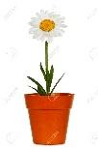
Community Connection Initiative:
Growing a Community Garden
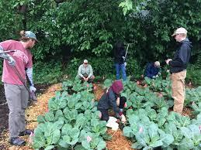
What is a community garden?
Community gardens provide space for members to grow fresh, healthy food close to home. They provide space for powerful neighborhood-level social change.
Community gardens have been a long-standing tradition. During WWII, victory gardens were an important source of food for families. Gardens can also be located on a school campus, library, or park.
What are the benefits?
- They bring places to befriend your neighbors. They would also be a place to recruit new club members.
- They are places to learn. Host gardening classes, instructional tours, or place the garden in a school yard.
- They are sites for restoring and building health. It is considered mild to moderate exercise. There are studies showing it also benefits mental health for people of all ages.
- They are a place to practice teamwork.
- They are a place for children (and adults) to explore nature, sometimes in the middle of an urban area.
- They empower us to organize and advocate for ourselves and our community.
- They provide the opportunity for people in marginalized groups to fully participate and to take on leadership roles.
- They create the opportunity to identify community assets and to build networks.
- They provide space to carry on our food cultures.
- They provide a space to grow low-cost, fresh fruits and vegetables for people without space to garden at home.
- Produce can be grown to donate to local shelters and those in need.
- Creates habitats for plants and animals and improves the ecology of the area.
- Helps to improve air and soil quality.
- Reduces food miles that are required to transport nutritious food.
- Impacts the lower social-economic residents by increasing access to fresh food, improving food security, improving dietary health, and increasing physical activity.
- Decreased crime rates.
- Teaches useful skills in planning, food production and business.
- Beautify and improve vacant land property values.
How can your club create a community garden?
Research grants provided by the USDA’s Cooperative State Research, Education and Extension Service or area botanical gardens.
Connect with the National Gardening Association to learn more about plant-based education at www.garden.org.
Find useful links at the American Community Garden Association’s website: www.communitygarden.org.
Read about these successful community gardens as you plan your garden: Del Paso CA, San Diego CA, Portand OR, CA Plan, http://nesfp.org/sites/default/files/uploads/guide_to_community_food_projects.pdf, https://www.dhs.wisconsin.gov/physical-activity/foodsystem/gotdirt.htm, and http://www.seattle.gov/neighborhoods/ppatch.
States can offer the “Gold Shovel” Award for those clubs who initiate a community garden.

